**SQL Queries :**

create table order_details (order_details_id int not null, order_id int not null, pizza_id text not null,

quantity int not null, primary key(order_details_id) );

select * from pizzahut.pizzas;

select * from pizzahut.pizza_types;

select * from pizzahut.order_details;

**BASIC**

**1. Retrieve the total number of orders placed.**

select count(order_id) as total_orders from orders;



**2. Calculate the total revenue generated from pizza sales.**

select

round(sum(order_details.quantity * pizzas.price),2) as total_sales

from order_details join pizzas

on pizzas.pizza_id = order_details.pizza_id;



**3. Identify the highest-priced pizza.**

select pizza_types.name, pizzas.price

from pizza_types join pizzas

on pizza_types.pizza_type_id = pizzas.pizza_type_id

order by pizzas.price desc limit 1;



**4. Identify the most common pizza size ordered.**

Select pizzas.size, count(order_details.order_details_id) As order_count

from pizzas join order_details

on pizzas.pizza_id = order_details.pizza_id

group by pizzas.size order by order_count Desc ;

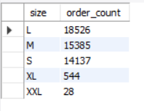

**5. List the top 5 most ordered pizza types along with their quantities.**

Select pizza_types.name,

Sum(order_details.quantity) as quantity

from pizza_types join pizzas

on pizza_types.pizza_type_id=pizzas.pizza_type_id

join order_details

on order_details.pizza_id=pizzas.pizza_id

Group by pizza_types.name

order by quantity desc limit 5;

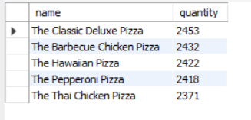

**Intermediate:**

**1. Join the necessary tables to find the total quantity of each pizza category ordered.**

Select pizza_types.category,

Sum(order_details.quantity) As quantity

from pizza_types join pizzas

on pizza_types.pizza_type_id = pizzas.pizza_type_id

join order_details

on order_details.pizza_id =pizzas.pizza_id

Group by pizza_types.category order by quantity desc;

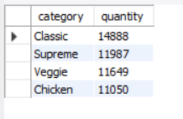

**2. Determine the distribution of orders by hour of the day.**

Select hour(order_time) As hour,count(order_id )As order_count from orders

Group by hour(order_time);

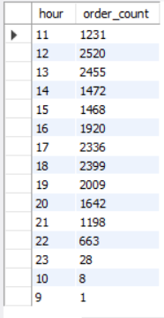

**3. Join relevant tables to find the category-wise distribution of pizzas.**

Select category , count(name) from pizza_types

group by category;

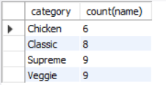

**4. Group the orders by date and calculate the average number of pizzas ordered per day.**

Select round(avg(quantity),0) as avg_pizza_ordered_par_day from

(Select orders.order_date, Sum(order_details.quantity) as quantity

from orders join order_details

on orders.order_id = order_details.order_id

group by orders.order_date ) as order_quantity

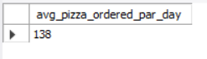

**5. Determine the top 3 most ordered pizza types based on revenue.**

Select pizza_types.name,

sum(order_details.quantity * pizzas.price) As revenue

from pizza_types join pizzas

on pizzas.pizza_type_id = pizza_types.pizza_type_id

join order_details

on order_details.pizza_id = pizzas.pizza_id

group by pizza_types.name order by revenue desc limit 3;

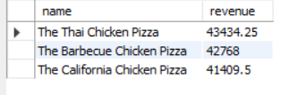

**Advanced:**

**1. Calculate the percentage contribution of each pizza type to total revenue.**

SELECT

pizza_types.category,

(SUM(order_details.quantity * pizzas.price) / (SELECT

ROUND(SUM(order_details.quantity * pizzas.price),

2) AS total_sales

FROM

order_details

JOIN

pizzas ON pizzas.pizza_id = order_details.pizza_id))*100,2 as revenue

FROM

pizza_types

JOIN

pizzas ON pizza_types.pizza_type_id = pizzas.pizza_type_id

JOIN

order_details ON order_details.pizza_id = pizzas.pizza_id

GROUP BY

pizza_types.category

ORDER BY

revenue DESC;

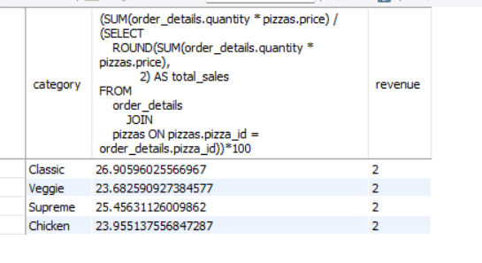

**2. Analyze the cumulative revenue generated over time.**

select order_date,

sum(revenue) over(order by order_date) as cum_revenue

from

(Select orders.order_date,

sum( order_details.quantity * pizzas.price) as revenue

from order_details join pizzas

on order_details.pizza_id = pizzas.pizza_id

join orders

on orders.order_id = order_details.order_id

group by orders.order_date) as sales;

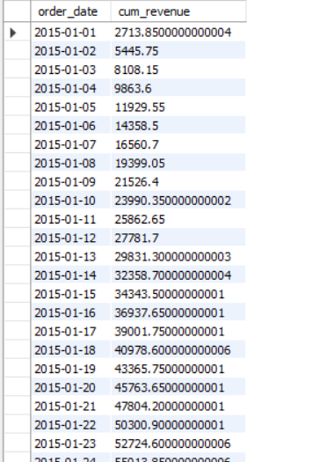

**3. Determine the top 3 most ordered pizza types based on revenue for each pizza category.**

Select name, revenue from

(Select category,name,revenue,

rank() over (partition by category order by revenue desc) as rn

from

(Select pizza_types.category, pizza_types.name,

Sum(order_details.quantity* pizzas.price) as revenue

from pizza_types join pizzas

on pizza_types.pizza_type_id = pizzas.pizza_type_id

join order_details

on order_details.pizza_id = pizzas.pizza_id

group by pizza_types.category, pizza_types.name) as a) as b

where rn <= 3;

